Title. “Variability in gait analysis comes more from the axis definition than movement itself”

Technical note

**Introduction**.

Kinematic data relative to joint motion is computed by evaluating the continuous movement of one segment with respect to its adjacent. This motion have been typically expressed using two mathematical methods: the Euler sequence (ref Chao 1980 + ISB) and the attitude vector, also commonly referred as helical axis or screw axis (Woltring, 1991). The Euler sequence represents the overall joint movement through a set of three rotations about three joint axes, one embedded in the proximal segment, one ‘floating’ (mutually orthogonal to the two others) and one embedded in the distal segment with respect to the joint. Due to its easy interpretability it has been recommended as a gold standard in clinical gait analysis (Wu & Cavanagh, 1995). This recommendation has been recently extend to the interpretation of the joint (i.e. intersegmental) moment (Derick et al. 2020). However, the decomposition of the overall movement into a sequence of three rotations are known to be prone to non-linear error propagation (Ge Wu, 2002) which results in the well-known “cross-talk” kinematic effect (Baudet et al., 2014; Flux, van der Krogt, & Harlaar, 2017; Pothrat et al., 2015). In terms of error or uncertainty propagation, it can be understood that the variability obtained on the Euler angles depends on the intrinsic variability of the joint motion (as measured from skin markers, that is to say also subject the soft to tissue artefact) as well as on the extrinsic variability of the three joint axes. The intrinsic variability of the joint motion is typically comprised in the attitude vector representation.

Reproducibility studies have been performed in the literature to evaluate different sources of variability in gait analysis (McGinley, Baker, Wolfe, & Morris, 2009; Wren, Gorton, Õunpuu, & Tucker, 2011). Some studies have performed sensitivity analysis on the joint axes for a given joint motion (Della Croce, Cappozzo, & Kerrigan, 1999; Fonseca, Gasparutto, Leboeuf, Dumas, & Armand, 2020) but no attempt have been made to separate intrinsic and extrinsic variability from test re-test data. For instance, measurement error is defined as the difference between the true value and the measured value. This difference is caused by uncertainties which characterises the dispersion of the possible measured values. The uncertainty associated to a measurement is caused by the combinations of errors around the estimated value of the measurement (Farrance & Frenkel, 2012). The smaller is the uncertainty, the closest the measurement from the real value. Therefore, the global variability in gait analysis can be affected by the combination of different parameters: the definition of the three Euler axis of rotation, the movement variability and the definition of the three axis that define the orientation of the segment (ref?). The intrinsic variability is linked with the movement of the joint motion, independently of any coordinate system, and can be assessed by looking at the joint angles about the helical axis and the deviation of the helical axis with respect to its average orientation during the movement. The variability added by the joint axes can be can assessed by looking at the corresponding joint angles computed by projection of the attitude vector on these axes. This way, the theoretical propagation of uncertainty can be studied as the equations linking the joint angles, the joint axes, and the attitude vector can easily established (without sine and cosine) (Farrance & Frenkel, 2012). The variability obtained for these joint angles and the more classically computed Euler angles can be compared to ensure the generalization of the results. The knee joint motion during gait is considered a typical test case according to the cross-talk effect.

We hypothesise that the variability in gait analysis is more dependent on the axis definition than the intrinsic movement variabitity. Thus, the aim of this study is to compare the variability of gait analysis expressed into a single helical axis and joint motion expressed into a set of three Euler rotations. Additionally, we want to understand the how the errors inherent to gait analysis influence the reproducibility of the kinematic results.

**Methods**.

A theoretical relationship between the parameters was analysed to understand the propagation of uncertainty on the definition of the Euler angles. The equation 1 describes the composition of the helical angle in function of the three angles of rotation and segment orientation while the equations 2, 3 and 4 defines the decomposition of the helical angle into the three Euler angles, thus, ɵ1, ɵ2, ɵ3 are the flexion-extension (Theta1), abduction-adduction (Theta2) and internal-external rotations (Theta 3) angles respectively. Moreover, *e1, e2, e3* represents the flexion-extension, medial-lateral and antero-posterior axes of the joint, and kɵ the joint angles. The symbols “*x”* and “.” design cross product and dot product respectively.

|  |  |  |
| --- | --- | --- |
|  |  | (1) |
|  |  | (2) |
|  |  | (3) |
|  |  | (4) |

The general expression for a measurand *y* in terms of input quantities (*x1, x2, … , xn)* isrepresented in equation 5*.*  Furthermore, the equation 6 describes the squared standard uncertainty of *y* by appropriately combining the squared standard uncertainties of the input quantities. Where represents the squared standard uncertainty to be calculated in function of each parameter, equivalent to the variance (Farrance & Frenkel, 2012). The variables and represents the denominator and numerator of the equations defining the Euler angles (Eq. 1-3), respectively.

|  |  |  |
| --- | --- | --- |
|  |  | (5) |

|  |  |
| --- | --- |
|  | (6) |

Translating those equations to the measurand units described before (equations 2-4), thirteen input quantities were identified: one single helical angle of the joint ( three components of the attitude vector (kx, ky, kz); three components of the flexion-extension axis (e1x, e1y, e1z); three components of the medial-lateral axis (e2x, e2y, e2z); and three components of the antero-posterior axis (e3x, e3y, e3z). While the helical axis and attitude vector are variable by the movement, the remaining quantities represent the axis definition of the segment. In order to simplify the calculations and following trigonometric rules, the definition of medial-lateral axis (e2) is defined as the orthogonal vector of the flexion-extension (e1) and antero-posterior axis (e3) as described in the equation 7.

|  |  |  |
| --- | --- | --- |
|  | |  |
|  |  | | (7) |

Following the same principle, the remaining axis were also decomposed. Each axis is composed by three components in space, normally considered as x, y and z and by following the same principle as above, one of the components can be calculated as the orthogonal between the remaining two components. Thus, equations (5-7) were used to simplify the axis definition. Finally, the initial input quantities were reduced then reduced to eight…

|  |  |  |
| --- | --- | --- |
|  |  | (8) |
|  |  | (9) |
|  |  | (10) |

**Data Collection**

Data was collected from a single asymptomatic healthy adult (add subject info) over five sessions performed by a single examiner within two months by a single examiner.

**Testing Procedure.**

The participant was equipped according to the Conventional Gait Model marker set (Baker, Leboeuf, Reay, & Sangeux, 2017) (12.5 mm) and asked to walk barefoot at a self-selected speed. A 12-camera motion capture system (Oqus7+, Qualysis, Göteborg, Sweden) tracked the marker trajectories at 100Hz. Gait kinematics was processed with the Vicon PiG clone, provided as CGM1.1 by the open-source library PyCGM2, which requires a static trial for calibration (Leboeuf et al., 2019).

The rotation matrix from Euler angles was then extracted as well as the attitude vector (k) and helical angle (ɵ). The attitude vector about the Euler angles was calculated (kɵ). Finally, the mean quantities were extracted per session. Root mean square deviation was applied to calculate the inter- and intra-session variability for Euler angles, projected ktheta, helical angle and helical axis variation. Then, the symbolic equations described above were defined using Matlab® (The Mathworks, Inc, Massachusetts) and then replaced by the calculated values. Finally, the remaining theoretical parameters were only the squared standard uncertainties (SSU) of helical angle (ssuɵ), attitude vector (ssuk), flexion-extension axis(ssue1) and antero-posterior axis(ssue3). Initially, each one of those was tested with a value of 5° independently (Della Croce et al., 1999; van den Bogert, Reinschmidt, & Lundberg, 2008), while the remaining ones defined as zero. Then the overall equations for uncertainty of the three Euler angles (Eq. 6) were calculated. From there, the theoretical corridor calculated was plotted together with the mean and standard deviation (experimental corridor) of the inter-session kinematics of the knee. The theoretical corridor is dependent on the four parameters of SSU and an eventual exact superposition of the two corridors would mean a close representation of the experimental error.

Statistical Analysis

**Results**.

Table 1 represents the RMSD for the experimental variability calculated inter- and intra-session.

The figure 1 (top) represents the overall intrinsic variability observed on the knee joint among one session. It is obtained by plotting the corridor of the helical angles () obtained during gait, the second plot represents the deviation of the helical axis with respect to its average orientation. The figure 1 (bottom) represents the variability added by the joint axes and it represented by the three considered Euler angles compared with the projection of the helical axis over those axis.

The figure 2 demonstrates the impact of the SSU parameters in study. On each one of the four situations, one of those parameters is set to 5°, value considered as general variability commonly reported, while the three remaining parameters were set to zero. The mean and standard deviation (experimental error) of the kinematics and the resultant theoretical error were plotted for each analysis.

|  |  |  |  |  |  |  |  |  |
| --- | --- | --- | --- | --- | --- | --- | --- | --- |
| Inter-Session – RMSD° | | | | | | | | |
|  | Helical Angle | Variation Helical Axis | Euler x | Projected KTheta x | Euler y | Projected KTheta y | Euler z | Projected KTheta z |
| Hip | 3.79 | 20.72 | 4.38 | 4.53 | 1.55 | 1.97 | 4.38 | 4.28 |
| Knee | 3.12 | 6.35 | 5.06 | 5.05 | 2.21 | 2.87 | 4.77 | 4.58 |
| Ankle | 3.36 | 12.63 | 4.85 | 4.98 | 5.02 | 4.99 | 4.61 | 4.48 |
|  |  |  |  |  |  |  |  |  |
| Intra-Session – RMSD° | | | | | | | | |
| Hip | 1.44 | 3.01 | 1.49 | 1.50 | 0.74 | 0.89 | 1.43 | 1.37 |
| Knee | 1.99 | 3.01 | 2.36 | 2.34 | 0.59 | 0.85 | 1.58 | 1.50 |
| Ankle | 2.02 | 9.06 | 2.12 | 2.17 | 1.73 | 1.73 | 2.25 | 2.24 |

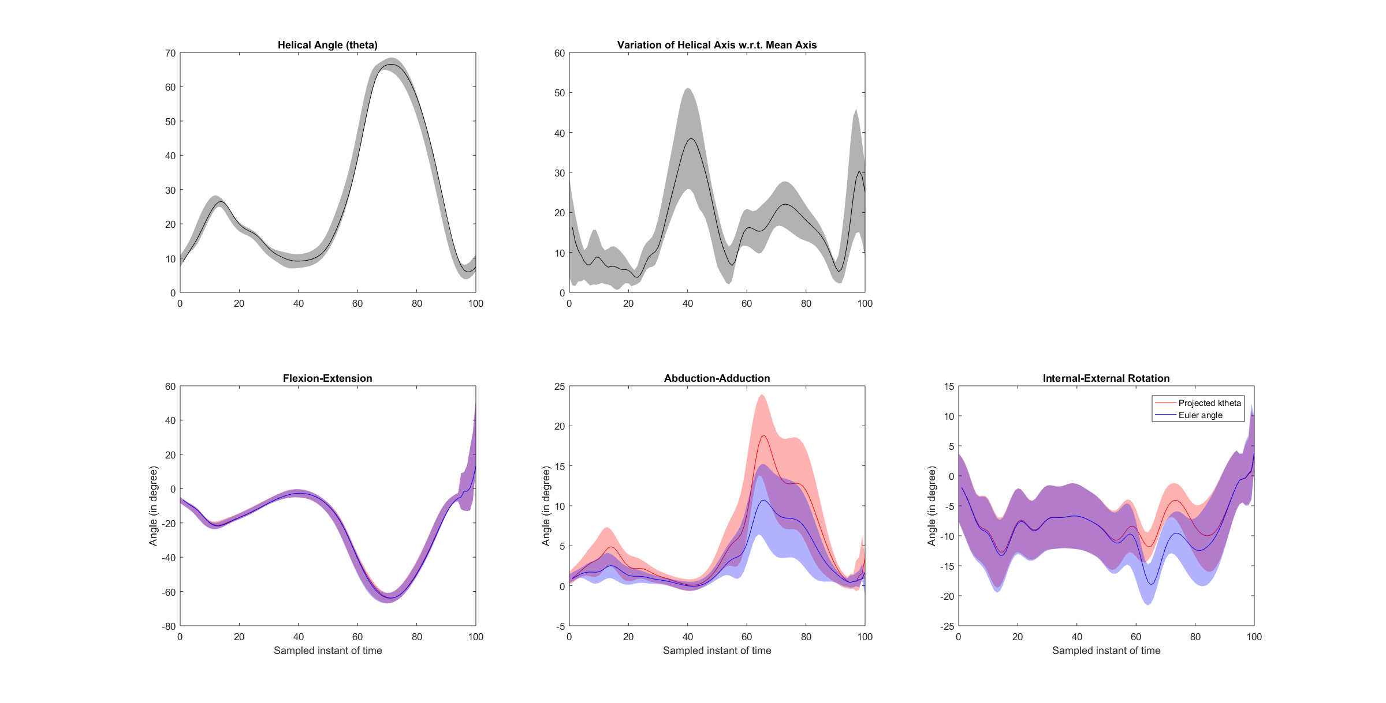Figure 1. Variability of Euler angles and projected ktheta.

Figure 2. Impact induced uncertainty (theta, k, e1, e3) in variability of kinematics. Four different analysis, defining individually the squared standard uncertainty (SSU) as 5° while the SSU of the rest of the parameters kept as zero. Mean (solid blue), standard deviation (blue corridor) represents the experimental error from overall sessions and the theoretical error corridor (red corridor) are plotted.

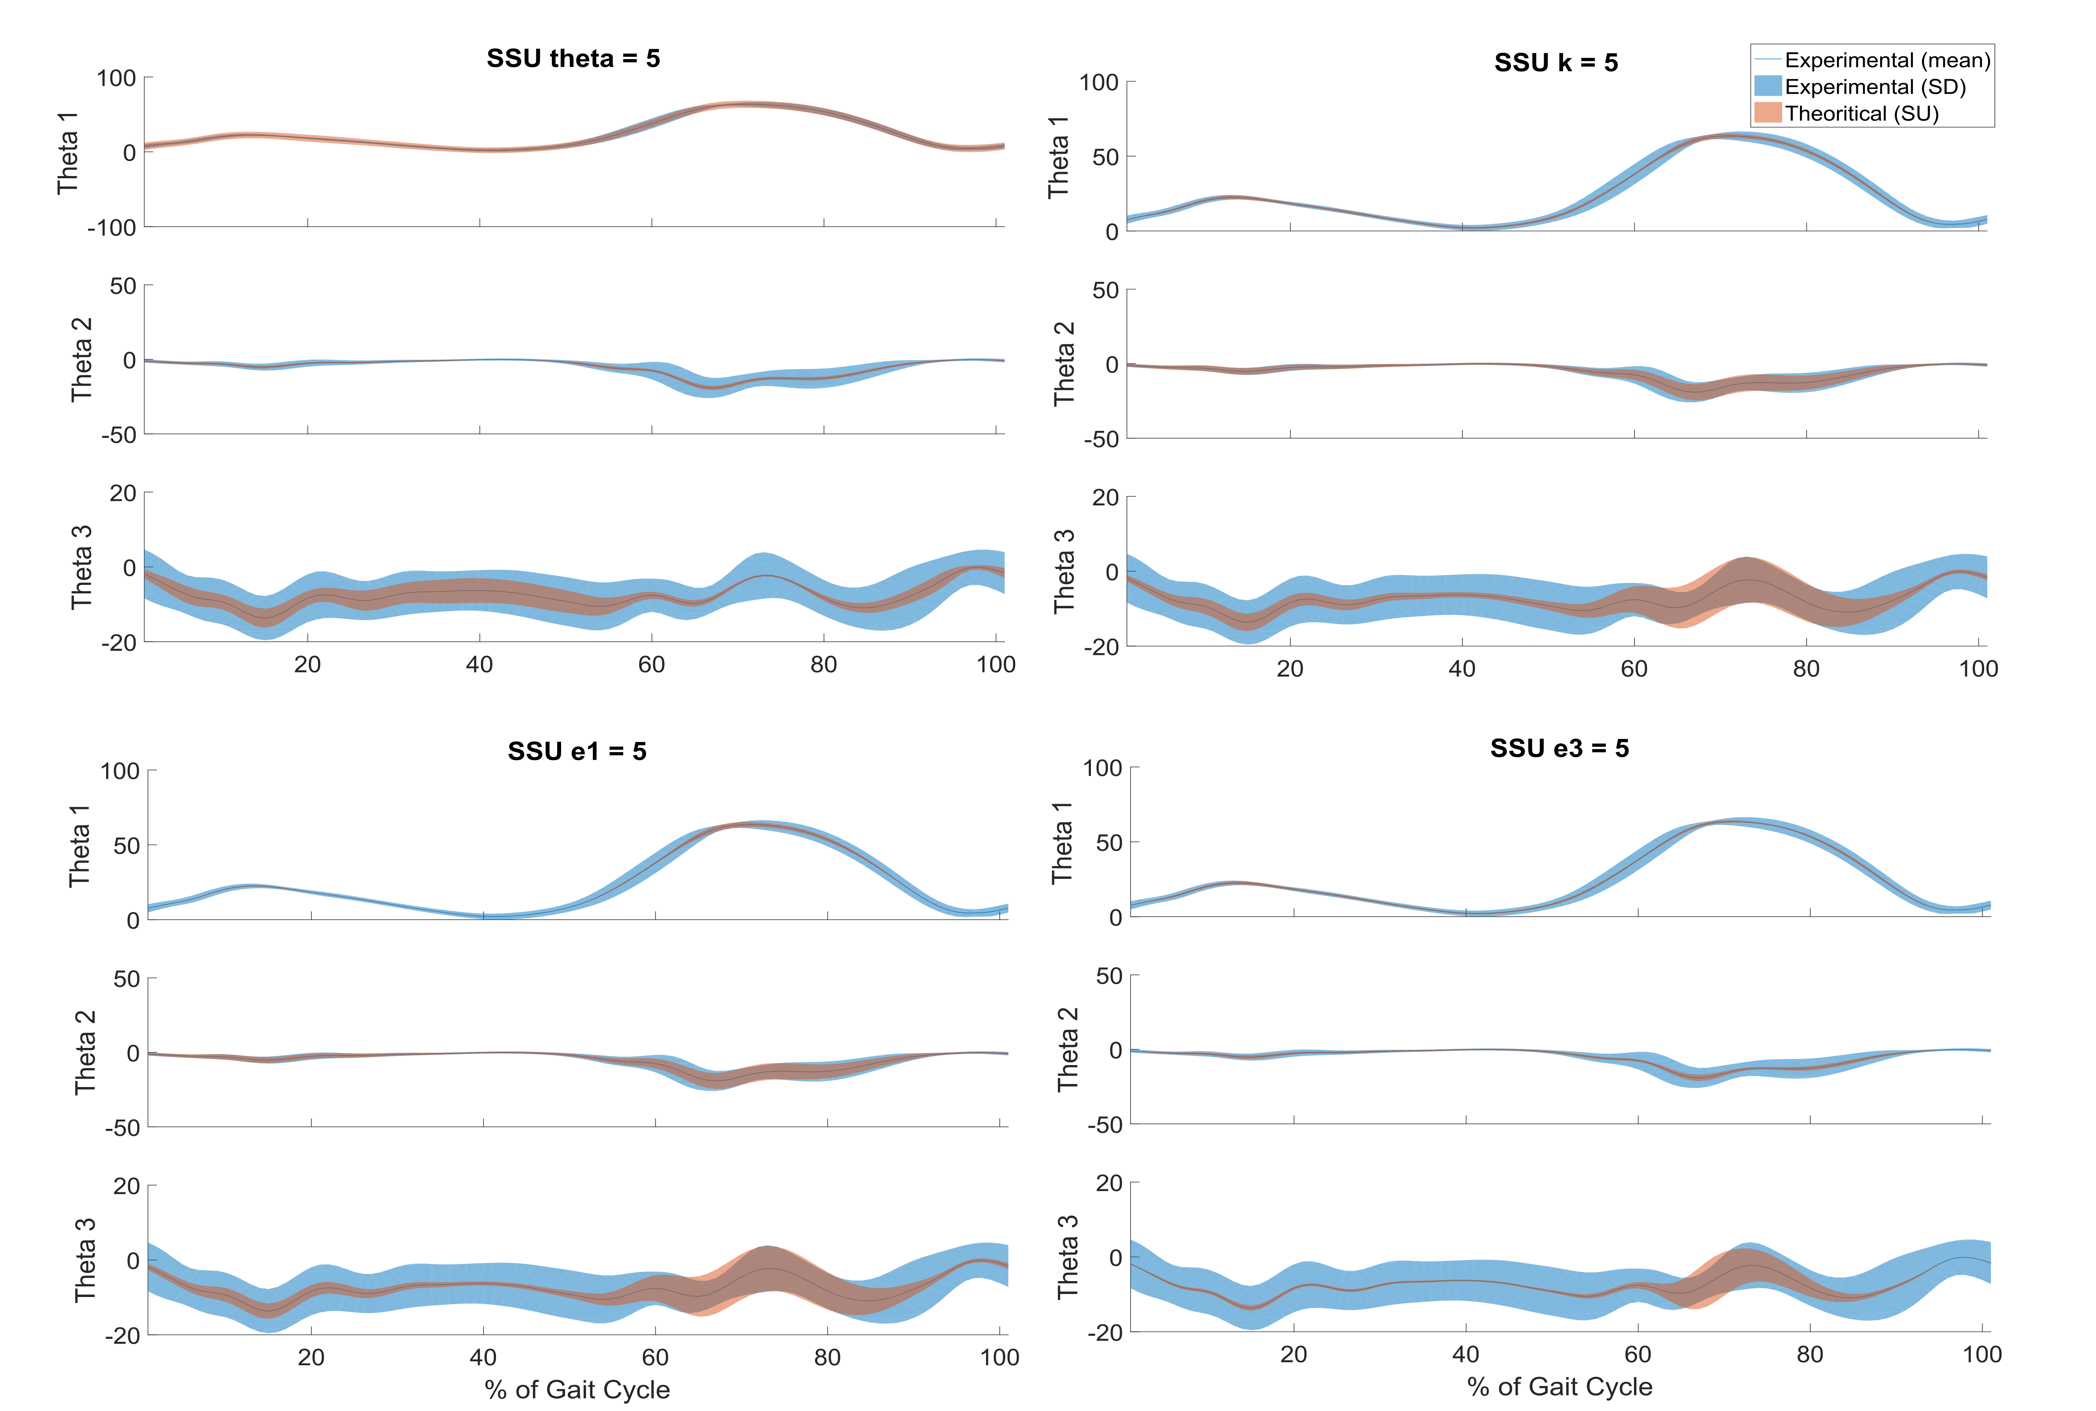

**Discussion**.

Current reproducibility in clinical gait analysis is generally accepted among the clinical community. However, some variability due to measurement error and intrinsic factors of the patient are observed (ref). This variability can impact the interpretation of the results (ref). Variability arise from three factors: 1) Definition of the axis of the each lower limb segment; 2) movement pattern variation among multiple trials; and 3) Definition of the axis of rotation (Euler angles). The uncertainty in placing the markers over the anatomical landmarks and soft tissue artefacts are the main causes of inaccuracy defining the joint centres and the axis of the segments. Therefore, movement pattern variation is caused by the capability of the subjects to repeat the same gait patterns (movement) across trials which is also enhanced by the presence of motor disorders (ref). The experimental inaccuracy on marker placement is reflected as wrong definition on the orientation of the segment coordinate system. Consequently, part of the flexion-extension motion is translated to the abduction-adduction and internal-external rotation angles. This error is commonly known as the kinematic “cross-talk” effect (ref baudet 15) and leads to erroneous interpretation of the kinematic data. The figure (3) demonstrates that an error definition of the flexion-extension axis (e1) results in higher variability on the ab-adduction and internal-rotation angles than with the same error produced on the antero-posterior axis. The latter produces and impact more considerable on the internal-external rotation (theta3) angle on the early swing phase. In the one hand, variability in the flexion-extension angle is mainly dependent of SSUtheta (explanation?). On the other hand, variability in the ab-adduction angle (theta2) is more dependent on the SSUk and SSUe1 (explanation?).

Evaluating how the variability propagates is important to understand why some of the angles are, for instance, more uncertain than others.

**Conclusion**.

**References**

Baker, R., Leboeuf, F., Reay, J., & Sangeux, M. (2017). The Conventional Gait Model: The Success and Limitations. *Handbook of Human Motion*. https://doi.org/10.1007/978-3-319-30808-1

Baudet, A., Morisset, C., d’Athis, P., Maillefert, J.-F., Casillas, J.-M., Ornetti, P., & Laroche, D. (2014). Cross-talk correction method for knee kinematics in gait analysis using principal component analysis (PCA): a new proposal. *PloS One*, *9*(7), e102098. https://doi.org/10.1371/journal.pone.0102098

Della Croce, U., Cappozzo, A., & Kerrigan, D. C. (1999). Pelvis and lower limb anatomical landmark calibration precision and its propagation to bone geometry and joint angles. *Medical and Biological Engineering and Computing*, *37*(2), 155–161. https://doi.org/10.1007/BF02513282

Farrance, I., & Frenkel, R. (2012). Uncertainty of measurement: A review of the rules for calculating Uncertainty components through functional relationships. *Clinical Biochemist Reviews*, *33*(2), 49–75.

Flux, E., van der Krogt, M., & Harlaar, J. (2017). Reducing knee joint crosstalk using PCA correction. *Gait and Posture*, (xxxx), 1–2. https://doi.org/10.1016/j.gaitpost.2017.06.352

Fonseca, M., Gasparutto, X., Leboeuf, F., Dumas, R., & Armand, S. (2020). Impact of knee marker misplacement on gait kinematics of children with cerebral palsy using the Conventional Gait Model—A sensitivity study. *PLoS ONE*, *15*(4), 1–12. https://doi.org/10.1371/journal.pone.0232064

Ge Wu. (2002). ISB recommendation on definitions of joint coordinate system of various joints for the reporting of human joint motion - part I: ankle, hip, and spine. *Journal of Biomechanics*, *28*, 285–286. https://doi.org/10.1104/pp.900027.However

Leboeuf, F., Baker, R., Barré, A., Reay, J., Jones, R., & Sangeux, M. (2019). The conventional gait model, an open-source implementation that reproduces the past but prepares for the future. *Gait and Posture*, *69*, 126–129. https://doi.org/10.1016/j.gaitpost.2019.01.034

McGinley, J. L., Baker, R., Wolfe, R., & Morris, M. E. (2009). The reliability of three-dimensional kinematic gait measurements: A systematic review. *Gait and Posture*, *29*(3), 360–369. https://doi.org/10.1016/j.gaitpost.2008.09.003

Pothrat, C., Goislard de Monsabert, B., Vigouroux, L., Viehweger, E., Berton, E., & Rao, G. (2015). Quantifying foot deformation using finite helical angle. *Journal of Biomechanics*, *48*(13), 3716–3719. https://doi.org/10.1016/j.jbiomech.2015.07.044

van den Bogert, A. J., Reinschmidt, C., & Lundberg, A. (2008). Helical axes of skeletal knee joint motion during running. *Journal of Biomechanics*, *41*(8), 1632–1638. https://doi.org/10.1016/j.jbiomech.2008.03.018

Woltring, H. J. (1991). 3–D Attitude Representation: a Standardization Proposal *. *Communities*, *31*(40), 1–17. Retrieved from file:///D:/eric.desailly/Desktop/pdf en vrac/Woltring - 1991.pdf

Wren, T. . L., Gorton, G. E., Õunpuu, S., & Tucker, C. A. (2011). Efficacy of clinical gait analysis: A systematic review. *Gait and Posture*, *34*(2), 149–153. https://doi.org/10.1016/j.gaitpost.2011.03.027

Wu, G., & Cavanagh, P. R. (1995). ISB RECOMMENDATIONS IN THE REPORTING FOR STANDARDIZATION OF KINEMATIC DATA, *28*(10), 1257–1261.